PSA, Inc

Wireless 9000

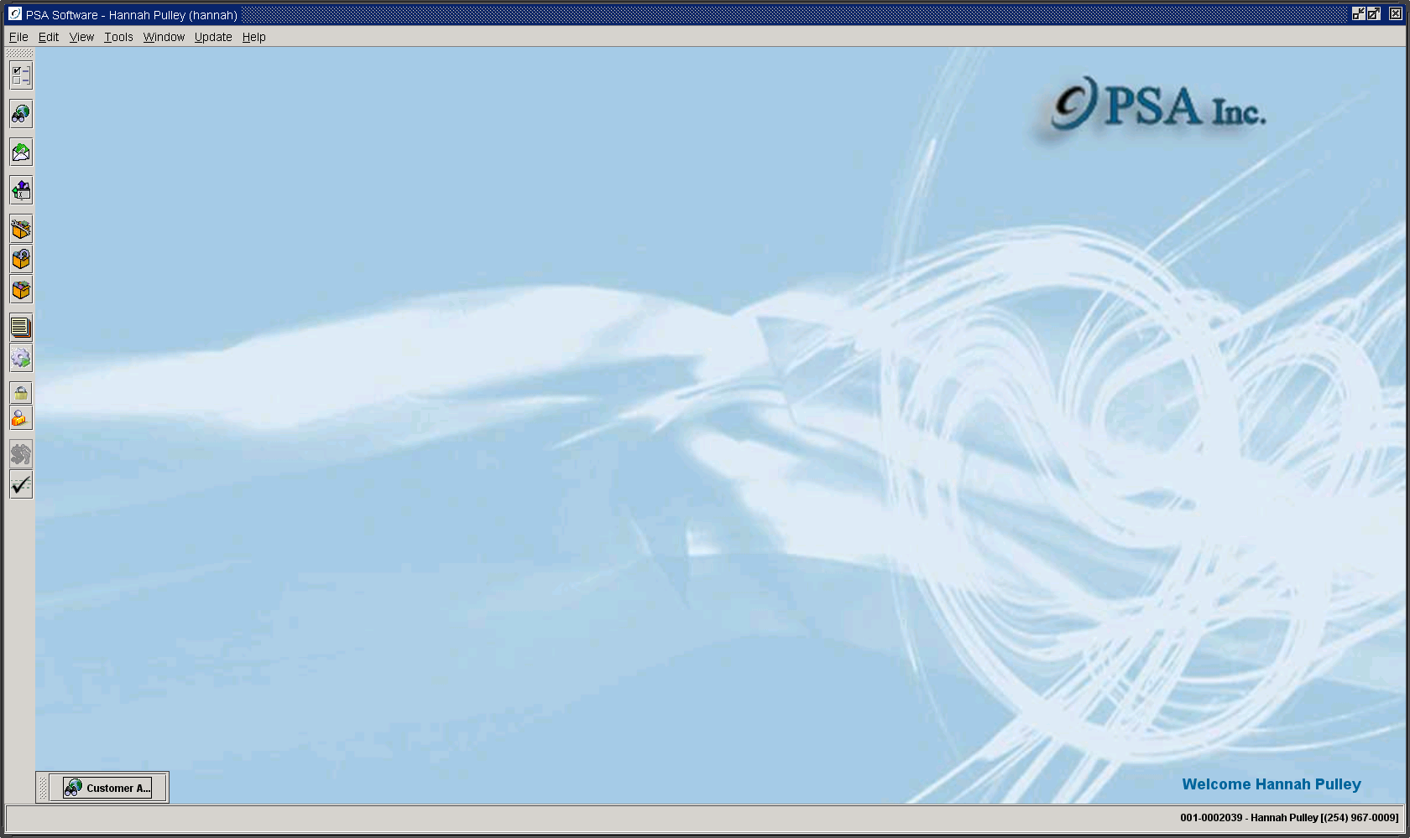
“Desktop”

Options Setup

Table of Contents

V2 Desktop Options Setup 3
CPNI Options 3
General Options Tab 3
Notification Options 5
CPNI Questions 7
Notification Text 8
User Defined Field Setup 10
Inventory Location 10
Customer Account 11
Service 12
Inventory Options 14
Point of Sale 15
Ticket Options 17

V2 Desktop Options Setup
Click on the Options Setup icon on the left toolbar.

CPNI Options
Some changes to fields trigger required CPNI notification. Remember any notification must not contain identifying information when send via SMS or Email. The text should be generic in nature. Ex. ‘A change has been made to your Anywhere Wireless account. If you did not authorize a change contact us immediately at (***) ***-****.

These fields trigger a CPNI notification in the PSA Desktop:
Account First Name
Account Last Name
Account Address 1
Account Address 2
Account Address 3
Account City
Account State
Account Zip
Account Email
Service MDN
CPNI Info - Username
CPNI Info - Password
CPNI Info - Pin

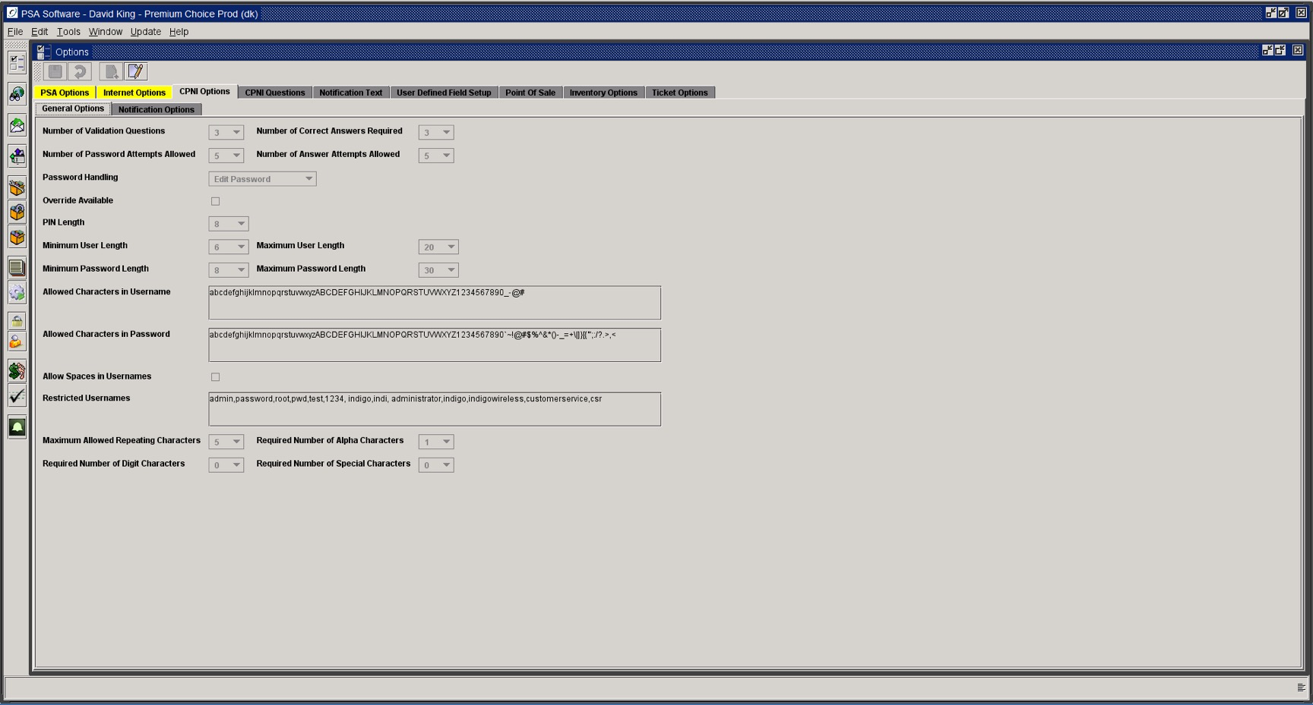

General Options Tab

Number of Validation Questions: Determines how many instances of the question drop-down boxes will be displayed. This is not the number of questions that you can create.
Number of Correct Answers Required: If you want to require more than one question be answered correctly before moving to the account, enter up to the number entered in Number of Validation Questions.
Number of Password Attempts Allowed: Determines how many attempts can be made entering the password before alternate questions and answers are displayed.
Number of Answer Attempts Allowed: Determines how many attempts can be made entering the answers to the questions before disabling the account or generating a new pin number.
Password Handling:
Generate Password: If requirements are met for questions and answers, a new pin number will be generated and sent to the customer. CSRs will not be able to access the account until the customer responds with the new pin number.
Edit Password: Allows the CSR to access the account and to change the password if requirements have been met on the questions and answers.
Override Available: Determines if a supervisor-level override dialog will exist in Desktop.
PIN Length: Set the length of the PSA generated PIN sent to customers on reset of password.
Minimum User Length: Select the minimum number of characters that can be used for the User Name.
Maximum User Length: Select the maximum number of characters that can be used for the User Name.
Minimum Password Length: Select the minimum number of characters that can be used for the Password.
Maximum Password Length: Select the maximum number of characters that can be used for the Password.
Allowed Characters in User Name: Show all alpha characters that can be used in creating a User Name. If certain alpha characters are not allowed remove them from the list.
Allowed Characters in Password: If certain alpha characters are not allowed, remove them from the list.
Allow Spaces in User Name: Determine whether you allow the creation of an User Name with spaces (Mike Smith versus Mikesmith).
Restricted User Names: PSA has some default user names that cannot be used elsewhere in the system. If you want to restrict certain user names, add those names in the list separated by a comma.
Maximum Allowed Repeating Characters: If you wish to restrict the number of repeating characters, set the number here. If the setting is 2, then 9111 would be invalid.
Required Number of Alpha Characters: If you want to further define the makeup of the user name and password by requiring a certain number of alpha characters, set that value here. If there are no additional requirements leave the field at ‘0’. By adding this restriction, the strength of the password will be increased.
Required Number of Digit Characters: If you want to further define the makeup of the user name and password by requiring a certain number of digit characters, set that value here. If there are no additional requirements leave the field at ‘0’. By adding this restriction the strength of the password will be increased.
Required Number of Special Characters: If you want to further define the makeup of the user name and password by requiring a certain number of special characters, set that value here. If there are no additional requirements leave the field at ‘0’. By adding this restriction the strength of the password will be increased.

Notification Options

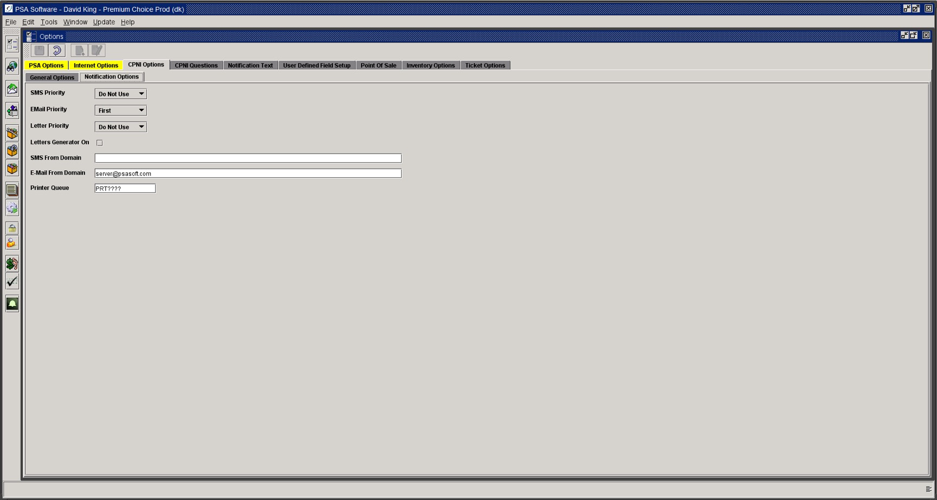

SMS Priority: Indicate the priority of notification as related to the other two types.
Email Priority: Indicate the priority of notification as related to the other two types.
Letter Priority: Indicate the priority of notification as related to the other two types.
Priority levels are: First, Second, Third and Do Not Use. If your company does not want to use one or more of the notification types, use the Do Not Use priority. As you change the priority on an item, the item that previously had that status will be set to Do Not Use. You will need to reset a priority for that item.
Letter Generator On: If the box is checked, the CPNI Letter/Postal Notifications will print to a designated printer. (Printer Queue below). As notifications are generated they will print automatically. If the letter generator is unchecked (off), the letters will still be generated but they will remain in the printer queue until someone restarts the letter generator.
SMS From Domain: This is a data area that defines the sending address for SMS messages. (ex. @sms.wcc.net or @mynwmcell.com)
Email From Domain: This is a data area that defines the sending address for Email messages. (ex. server@wcc.net or server@nwmc.com)
Printer Queue: This sets the default printer for printing the letter/postal notifications.

Each time a change is made to a CPNI, a record is written to a file, AUDITTBL. This table stores the account number, date, time, type of change (MDN change, Address change), the original entry in the field, and the new value for the field. For CPNI the following fields are captured by default. MDN, MIN, IMSI, provisioning type, service type, customer name, address lines 1-3, City, State, Zip, user name, password, questions 1-3 and answers 1-3. In addition to those fields, PSA can set other field changes to write records to the audit table. Currently, additional fields are: driver license number, email address, social security number, commitment expiration date, contract length, contract start date, maintenance contract expiration date, and equipment serial number (ESN, MEID, IMEI). If you wish to track the optional item changes and send notifications, you will need to notify PSA. You can see these changes recorded in the audit table for an individual by going to the Reports Tab on the specific customer and selecting Change Report.

If there are no valid CPNI notification options due to setup or date restrictions, the system will email a message to someone within the company. This message will state generically that the automated notification has failed and the customer needs to be notified by someone in the company. The message will contain the customer name and account number. This CPNI auto notification email needs to be set up in Program Email Notification setup under General Information setup. Set up using ‘NOTIFYERR’ as the program name.

CPNI Questions

Choose the CPNI Questions tab. Here the company defines the questions for backup authentication to meet CPNI requirements.

Question: Enter up 250 characters.

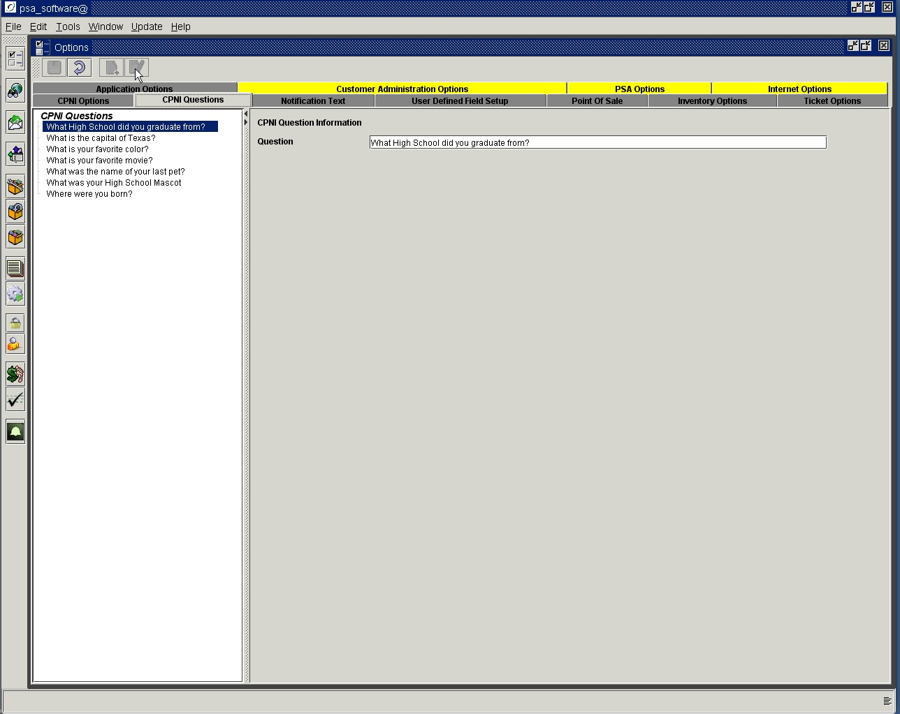

Notification Text

The text for the various notifications delivered by Wireless 9000 Desktop are defined here. In regards to CPNI, remember to keep the text very generalized per CPNI regulations. You may not disclose what type of change occurred, only that there was a change made to the account. Each type of notification used within your company must have text definition. If any particular method is not to be used then the note text for that option should not be setup. For example, if you only want a pin change notification to be sent by letter then only setup LETTERPIN for those notifications. The length of SMS messages will vary by company and phone type. Indicate the critical nature of the notification early in the message so customers won’t just ignore the notification. Indicate your company name and return call number. Some phones/systems allow as few as 100 characters, check with your technicians for message length restrictions. The Letter notifications only allow 40 lines of text. Email has no restrictions.

Types of notification are defined by PSA. If no text is provided for the type, the program will not consider that as a valid notification type. The hierarchy for the CPNI notifications is defined in the Company Information.

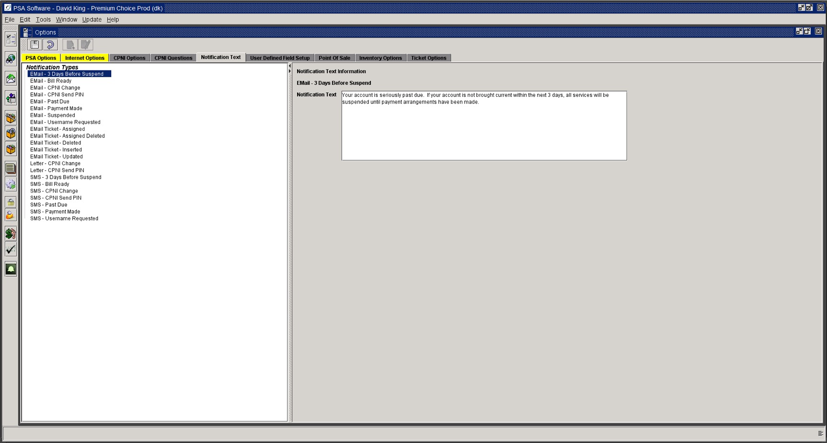

Using email notification requires that the customer record must have an Email Address of Record. That address is stored on the Account Level screen in the customer records. If the field is blank then no notification will be sent. We have no way to validate whether or not an email address is valid so please review the email address carefully when setting up new email addresses.

For SMS notifications the messages will be sent to the Phone of Record. This phone number can be viewed or edited on the CPNI Tab on the customer’s account. Messages can only be sent to one phone number.

You are able to customize the message adding the customer name by using <name> keyword and <account> to show the account number within the message.

Credit Card Expiration: This process checks for expiring credit cards and sends a notification to contact the company to update the information. The process checks a month in advance of the date chosen and runs a list that can automatically send the email or it will send to someone in the company for review.
Email – 3 days Before Suspension: This email will be send 3 days prior to the Suspension date set on the bill run.
Email – Bill Ready: This text is used to notify a customer, via email, that bill images are available on the PSA Website when the company opts to integrate the PSA web module into their system. (Ex. This notice is to inform you that your bill is now ready for viewing. Please log onto your account at http://xxx.xxx.xxx. Thank you.)
Email – CPNI Change: If the company chooses to use email as a valid notification type for CPNI messages, then this text will be sent whenever a CPNI sensitive field is changed on that customers account. (Ex. A change has been made on your ABC Wireless account. If changes were not authorized by you, please contact our office at 555-555-5555.)
Email – CPNI Send PIN: If the company chooses to send a new PIN, via email, when the customer cannot remember the account password, please set up the text here. The PIN will be appended to the end of the message. (Ex. NOTICE - A new password has been generated for your ABC Wireless account. If you have any questions, please call 555-555-5555. 23YM98ET)
Email – Past Due: If the treatment process is being used then when the past due notice marked for email is created the email will be sent. If the treatment process is not used the email is set for a specific day of the month and is sent to all past due customers.
Email – Payment Made: Enter text here to indicate that a payment has been posted to the customers account. (Ex. A payment to your account has been processed. Thank you for your business!)
Email – Send 2 Factor Authentication PIN: If theV3 application is accessed by open web browser, then a PIN code must be sent to authenticate the user for a period of time. If the PIN will be sent to the user email address in the user maintenance, enter the text here.
Email – Suspended: This email will be sent when the Treatment process has been completed and the service suspended.
Email – Username Requested: This text will be used if the customer cannot remember the username on the account when trying to access PSA’s EBPP website. If they request their username be sent to them, the system will use only the Email Address of record and send the username ONLY in the email. The username will be appended to the end of the text. (Ex. The user name for web access to your account is: MYUSERNAME123)
Email Ticket – Assigned: This notification will be sent to the assignee when a ticket has been assigned to them
Email - Assigned Deleted: An alert notification will be sent the assigned user that a ticket has been deleted
Email Ticket – Deleted: Sends email that a ticket has been deleted to the creator of the ticket
Email Ticket – Inserted: - Sends email to creator confirming ticket creation
Email Ticket – Updated: - Sends email to creator of the ticket when any update is done on the ticket
Letter – CPNI Change: If the company chooses to use regular postal mail as a valid notification type for CPNI messages, then this text will be sent whenever a CPNI sensitive field is changed on that customers account. The messages will be sent to a printer queue for printing on letterheads or form letters. PSA may have to help format the text to print properly on the letterhead. (Ex. A change has been made on your ABC Wireless account. If changes were not authorized by you, please contact our office at 555-555-5555.)
Letter – CPNI Send PIN: If the company chooses to send a new PIN via the US postal service when the customer cannot remember the account password, please set up the text here. The PIN will be appended to the end of the message. The messages will be sent to a printer queue for printing on letterheads or form letters. PSA may have to help format the text to print properly on the letterhead. (Ex. NOTICE - A new password has been generated for your ABC Wireless account. If you have any questions, please call 555-555-5555. 23YM98ET )
SMS – 3 days Before Suspension: This text will be send 3 days prior to the Suspension date set on the bill run.
SMS – Bill Ready: This text is used to notify a customer, via SMS/Text message, that bill images are available on the PSA Website when the company opts to integrate the PSA web module into their system. (Ex. This notice is to inform you that your bill is now ready for viewing. Please log onto your account at http://xxx.xxx.xxx. Thank you.)
SMS – CPNI Change: If the company chooses to use your text message system as a valid notification type for CPNI messages, then this text will be sent to the Phone of Record whenever a CPNI sensitive field is changed on that customers account. (Ex. A change has been made on your ABC Wireless account. If changes were not authorized by you, please contact our office at 555-555-5555.)
SMS- CPNI Send PIN: If the company chooses to send a new PIN, via SMS, when the customer cannot remember the account password, please set up the text here. The PIN will be appended to the end of the message. (Ex. NOTICE - A new password has been generated for your ABC Wireless account. If you have any questions, please call 555-555-5555. 23YM98ET)
SMS – Past Due: If the treatment process is being used then when the past due notice marked for SMS is created the text will be sent. If the treatment process is not used the SMS is set for a specific day of the month and is sent to all past due customers.
SMS – Payment Made: Enter text here to indicate that a payment has been posted to the customers account. (Ex. A payment to your account has been processed. Thank you for your business!)
SMS – Send 2 Factor Authentication PIN: If theV3 application is accessed by open web browser, then a PIN code must be sent to authenticate the user for a period of time. If the PIN will be sent to the user phone as a text message, enter the text here.
SMS – Username Requested: This text will be used if the customer cannot remember the username on the account when trying to access PSA’s EBPP website. If they request their username be sent to them, the system will use only the Phone of Record and send the username ONLY in the text message. The username will be appended to the end of the text. (Ex. The user name for web access to your account is: MYUSERNAME123)

User Defined Field Setup

Inventory Location

To define Inventory Locations highlight the item in the component tree.

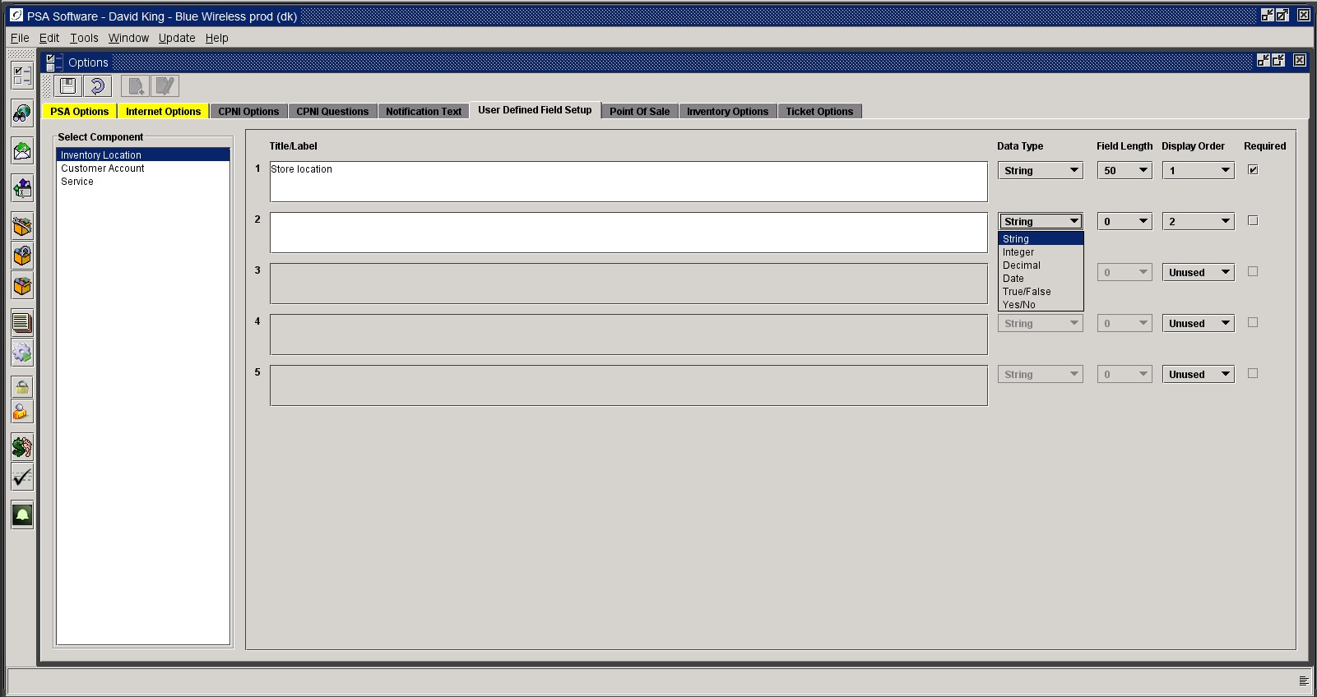

You can use these fields to add a main location and then create sub-categories under that location. When locating inventory, the fields that you create will be available to specifically define where an item is currently stored. The first field under Title/Label should be the broadest location, and every subsequent entry should be more specific. For example, you can set the first field to define what store (could be a store name or a store number) the item is in. The second field can define what room in that store the item is located, etc. To create a new field, you must first change the Display Order to something other than Unused.

Title/ Label: Enter the title or label attached to the field.
Data Types:
String: Select this option if the field will be alpha characters.
Integer: Select if this will be a whole number only.
Decimal: Chose this if this is a number field requiring decimal places, such as currency. (Not applicable to Location setup)
Date: Establishes the field as a date field, the calendar icon will bring up calendar. (Not applicable to Location setup)
True/False: Creates a check box on screen where the response to the field will be checked (yes) or uncheck (no). (Not applicable to Location setup)
Yes/No: Creates radio buttons for Yes and No on screen. (Not applicable to Location setup)

Field Length: Define the maximum length for the information that will be provided. 50 character max.
Display Order: Defines the order the fields will be shown in the application. ‘1’ will display first on the screen and so on.
Required: A check in the box requires the user to enter data in the field within the application.

Customer Account

This information will be shown on the User Defined fields on the Account screen. These fields will be the same on any service selected for the account. To create or add new fields to the tab, select the tab from the tree and press New or Edit in the tool bar. When all entries are complete, pressing the Save icon will retain the changes. Pressing the Cancel icon will ignore any changes and stop the editing process.

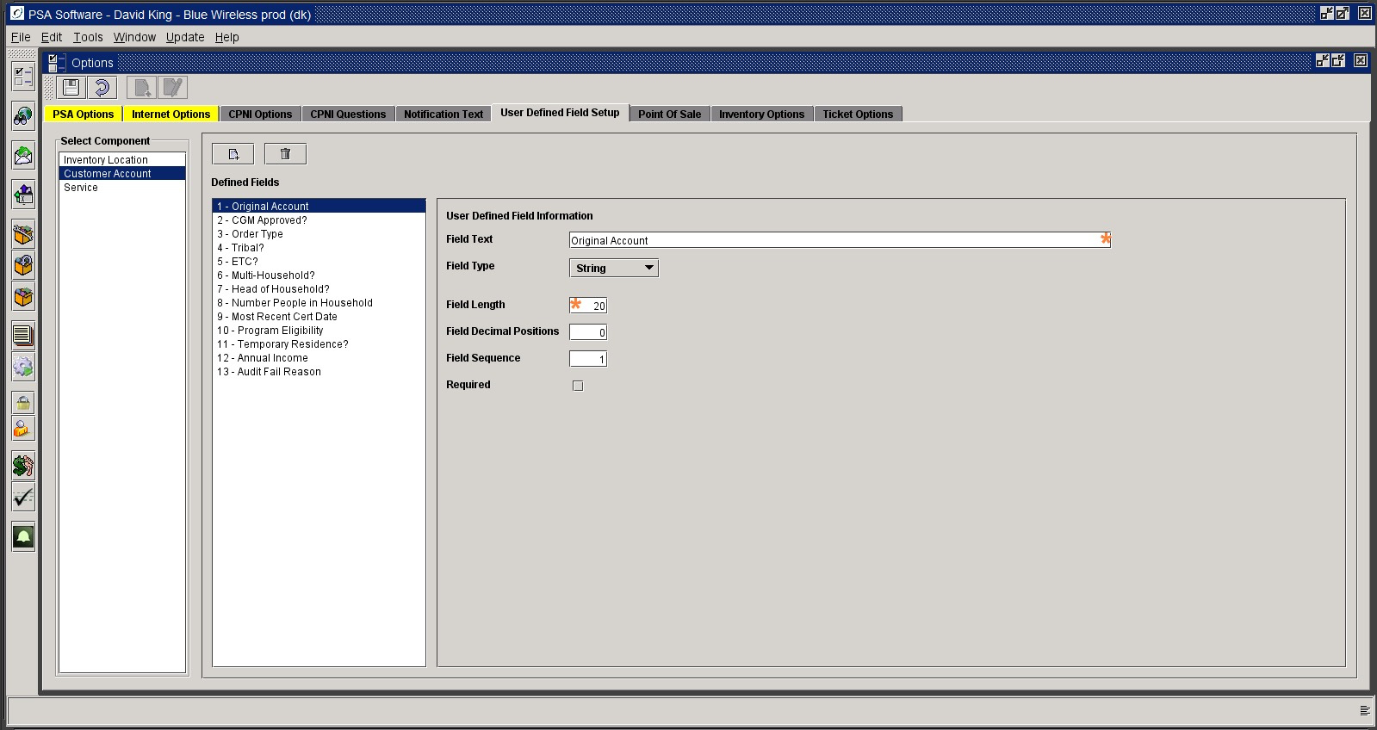

Field Text : This will be the label displayed next to the field on the User Defined Fields tab.
Field Type: Select from the dropdown box one of the following:
String – this allows for alphanumeric characters to be entered into the fields
Integer – allows only numbers to be entered
Decimal – would be used for currency fields and the number of decimals should be set
Date – creates a date field with the calendar icon.
True or False – creates a check box that can be selected
Yes or No – create radio buttons to select with the mouse
List – adds an additional selection, which creates a dropdown box on the tab where you can add user-defined items in the dropdown list. (see example below)
Field Length: This establishes the length of the field up to a max of 100 characters. This is not required for date, true/false, Yes/No or List.
Field Decimal Positions: This should be used for Decimal to establish the number of decimal places you want to use and display.
Field Sequence: This number determines the order in which the fields will display on the tab.
Required: If this field requires an entry by user before moving to the next function or screen then check this box.

Selecting List field type:

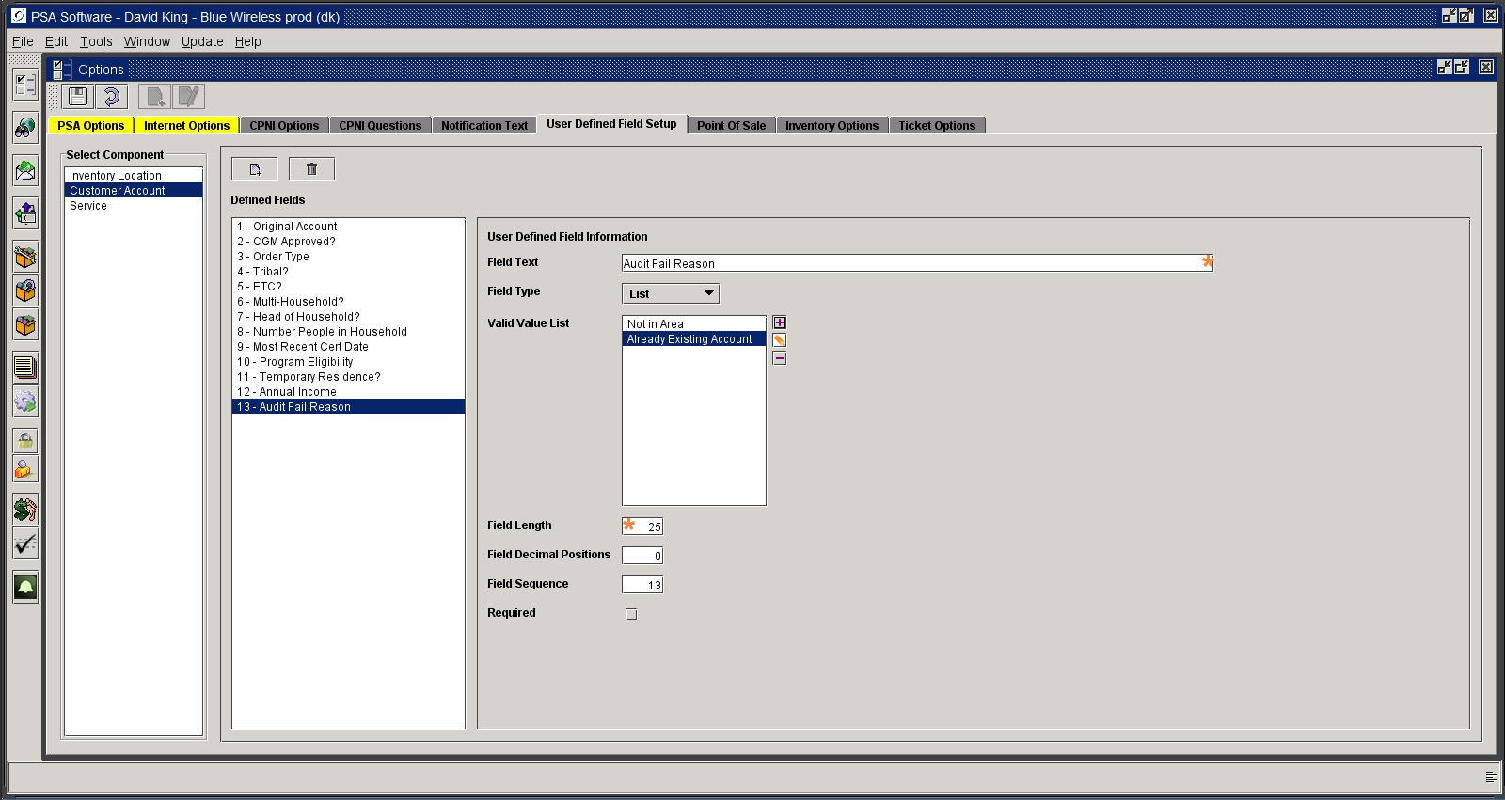

Use the ‘+’ sign to add something to the dropdown box.

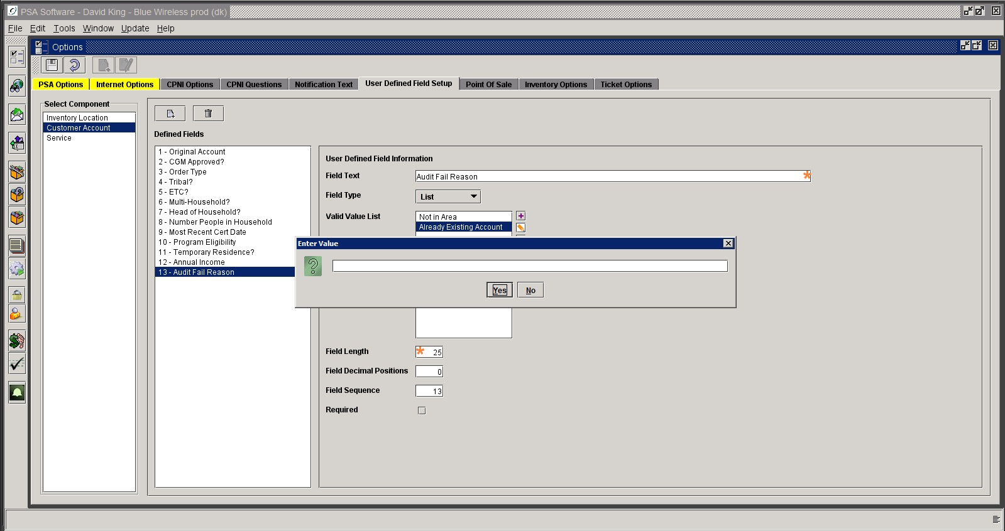

The middle icon allows you to edit the item you have selected and the ‘-‘ minus sign removes the highlighted items from the list.

Service

This section will define fields which are specific to the service number. These fields will display on the User Defined Fields tab on the Service Screen and are created the same as the User Defined fields for the account level. The fields here will only display information for the service number selected when opening the account information.

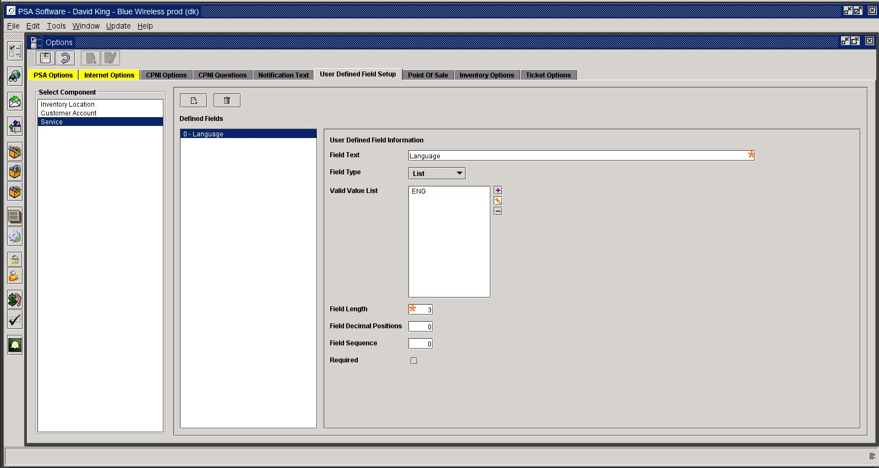

Inventory Options

Defines how items that do not exist in inventory will be handled and create the cost code used on PSA’s internal label.

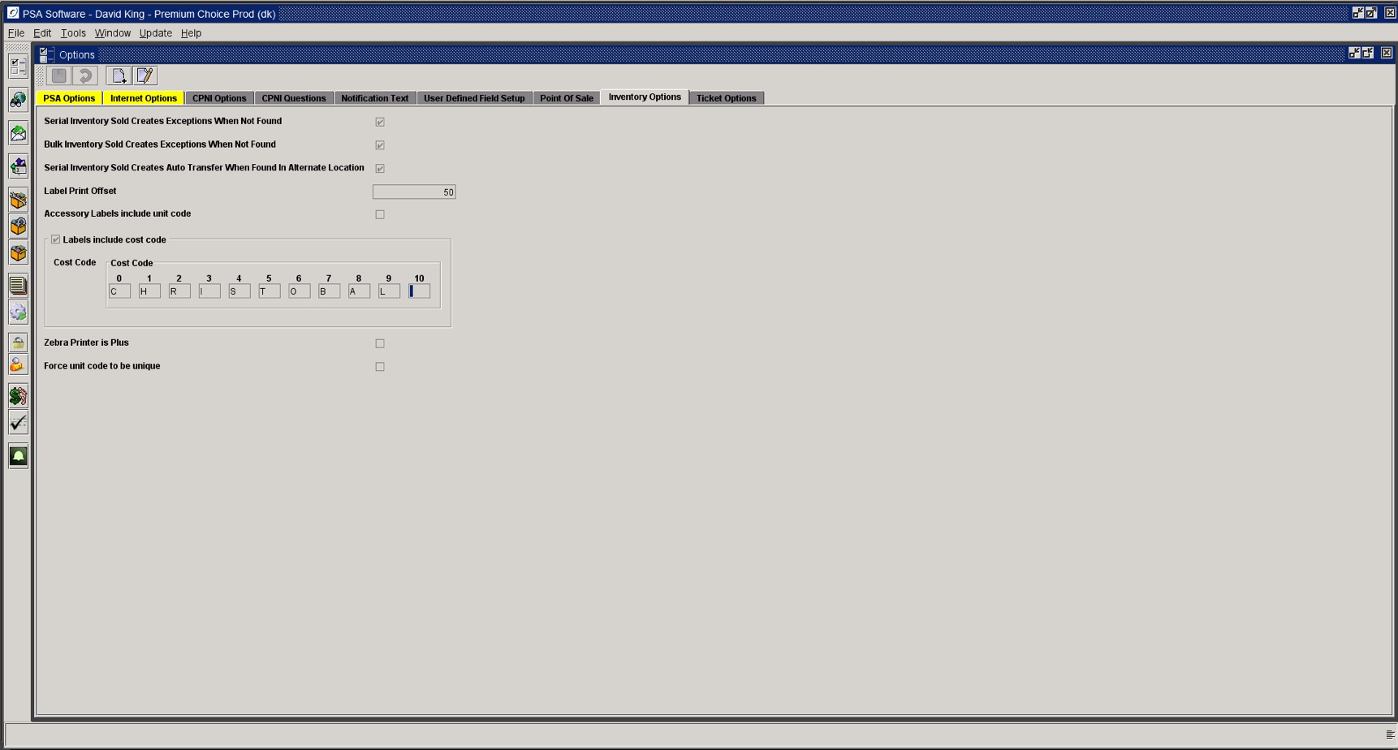

Serial Inventory Sold Creates Exception When Not Found: If a serial item is sold, but there is no record of the item in the inventory, an exception record will be created. Exception records can be viewed and the items can be reconciled in the inventory at a later time.
Note: Serial inventory is any inventory that has an identifying number or a serial number. For example, any item with an ESN, MEID, IMEI, ICCID (SIM number) or any other type of a serial number is considered serial inventory.
Bulk Inventory Sold Creates Exception When Not Found: If a bulk item is sold and there is no instance shown in the inventory, an exception record will be created.
Note: Bulk inventory is inventory without a serial number. For example, chargers, batteries, holsters, faceplates or any other type of accessory is a bulk item.
Serial Inventory Sold Creates Auto Transfer When Found in Alternate Location: If the item sold was found in another location’s inventory, the program will automatically transfer the item from the old location to the selling location when this option is selected.
Label Print Offset: Used to align the printing on PSA barcode labels (PSA will set if needed).
Accessory Labels include Unit Code: PSA printed labels will show the Unit Code defined on the Catalog Item setup.
Labels include cost code: If checked the cost price of the item will be shown on the PSA label in code.
Cost Code: Define the letters that correspond with 0-9 for the cost field on the inventory label. Using the code shown in the image above (CHRISTOBAL), the cost of an 85.99 item would be shown as ATLX, where 8 is A, 5 is T, 9 is L, and the second 9 is X. When a digit in the price is repeated (like 9 is in this example) the second repeated digit is coded as X. This code can be printed on an item’s label to show the CSR what the wholesale cost of the item is, without showing the customer how much the product was marked up. This is useful if your company allows negotiation of prices for customers. If the CSR can see that the item cost the company $85.64, he will know not to sell the item for less than that amount. However, using the cost code will keep the customer from seeing how much the price was marked up.
Zebra Printer is Plus: If your Zebra receipt printer is designated as a ‘PLUS’ then mark this field to adjust the printer output.
Force unit code to be unique: In catalog item setup the same unit code cannot be reused for additional items.

Point of Sale

Choose the Point of Sale tab.

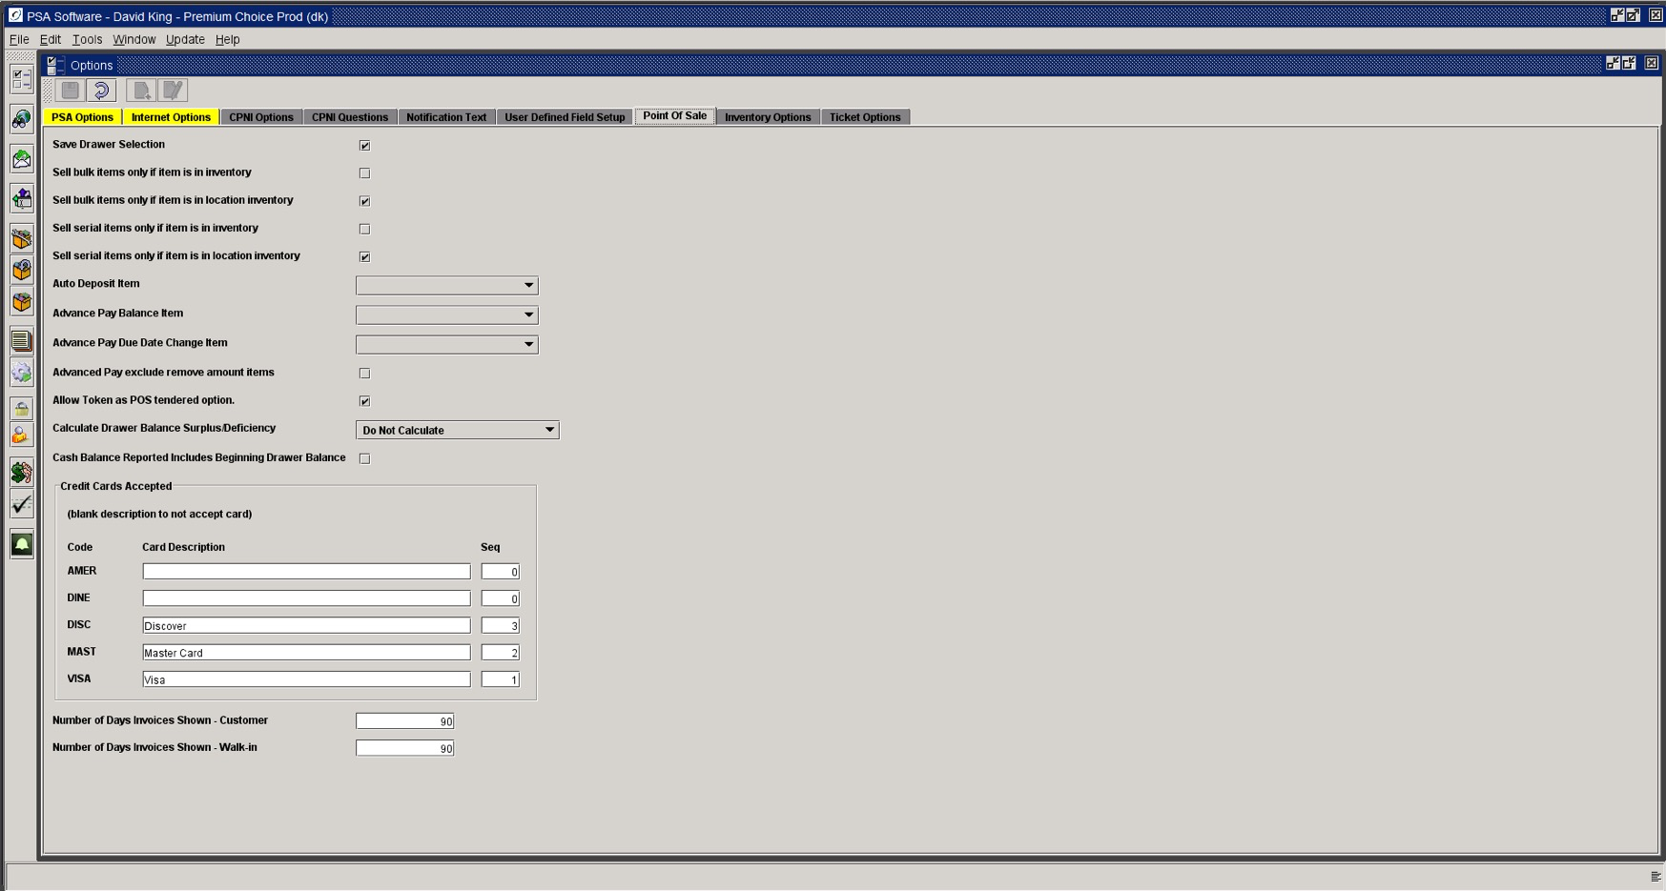

Save Drawer Selection: If this box is checked, the drawer is remembered when completing a Point of Sale transaction. If unchecked, the user will need to select a drawer each time a transaction is completed.

If none of the following options are set, any item that can be selected or scanned into the invoice will be allowed as a sale. If the exceptions creation rules are turned on, then the item will generate an exception record.
Sell serial items only if item is in inventory: If the item selected in Point of Sale is found anywhere in the inventory; the sale will be allowed.
Sell serial items only if item is in location inventory: An additional validation can be added in conjunction with the ‘Sell serial items only if item is in inventory’ where the item (1) must be in inventory and (2) must be in the location inventory defined on the drawer selection before the item can be sold.
Sell bulk items only if item is in inventory: If the item selected in Point of Sale is found anywhere in the inventory; the sale will be allowed.
Sell bulk items only if item is in location inventory: An additional validation can be added in conjunction with the ‘Sell bulk items only if item is in inventory’ where the item (1) must be in inventory and (2) must be in the location inventory defined on the drawer selection before the item can be sold.
Auto Deposit Item: Select the item to create a deposit if you are using the credit module, where the credit level defines and inserts a deposit on a New Customer insert or Add a Phone.
Advance Pay Balance Adjustment Item: If you want to consider the balance in Transaction History in Point of Sale calculations, then select the feature from the dropdown. This item will be displayed on the POS invoice showing how much of the existing prepay balance will be used in the transaction. Example if you want the credit balance of 5.24 to be used in the calculation of the amount owed in the POS transaction, select a company created feature (i.e. Prepay Balance Adjustment) here. Then in the Point of Sale, this will be added as a line item to the invoice, in addition to the rate plan charges, reconnect fees, etc. The balance from Transaction History will be used and will reduce the amount owed by 5.24. If you require they pay only full charges regardless of any balance in Transaction History, leave the field blank. If the balance is positive then that amount will be added so that it can be collected on the invoice.
Advance Pay Due Date Change Item: Select an item that will used to consolidate all the charges involved with changing a due date. This items will be the only item on the invoice and will include all charges from the current due date to a date in the future. This item will prorate the charges for all phones – all items until the new due date.
Advance Pay Exclude Remove Items: If your company does not prorate removes in the prepay arena then you need to check this box. This does not take into account any removal of a plan and forces the collection of the entire amount of the new plan in POS.
Allow Token As POS Tendered Option: Allow the option to use the credit card token on file to pay on an invoice.
Calculate Drawer Balance Surplus/Deficiency: Once the cash amounts have been entered the application will calculate the difference between the balance entered by the user and the computer calculated balances for cash and load either surplus or deficiency fields for review.
Cash Balance Reported Includes Beginning Drawer Balance (Y/N): If you do not want the beginning drawer balance to be considered in the drawer balance calculations for the report, mark this with a N.

Credit Cards Accepted defines what cards are shown in Point of Sale and on your EBPP website. If your company does not accept a certain card, leave the field blank. The card sequence determines what order the cards will display.

Number of Days Invoices Shown – Customer: This setting controls the history display of invoices in both the POS – Returns and in Documents>View Invoices. The application takes the current date and subtracts the number of days to find a starting point to display invoices.
Number of Days Invoices Shown – Walk-in: This setting controls the history display of invoices in the POS – Returns. The application takes the current date and subtracts the number of days to find a starting point to display invoices.

Ticket Options

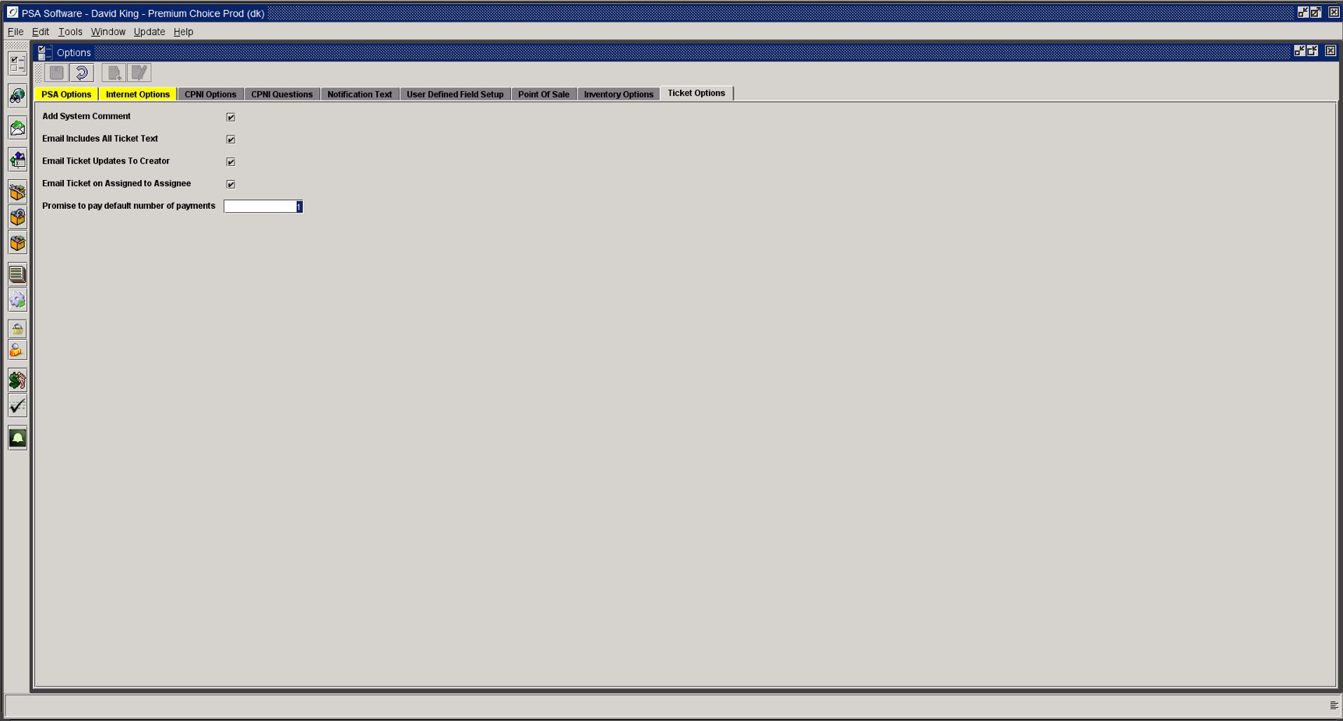

Add System Comment Y, N? If yes, the ticket creation will add a comment to either the account level or service level comments for additional reference.
Email Ticket Updates to Creator Y, N? If yes, any changes to the ticket after creation will be emailed to the original creator.
Email Ticket on Assigned to Assignee Y, N? If yes, a notification email is sent to the individual to whom the Ticket was assigned with designated information.
Email Includes All Ticket Text Y, N? If yes, then the body text of the Ticket will be included in the email notification not just the codes and assignments.
Promise to pay default number of payments: This determines the default value of the number of payments on the Promise to Pay ticket calculator.

